1. Connect RDS from private EC2 at private subnet. Private EC2 is to be connected from EC2 located at public subnet in user defined Virtual Private Cloud.

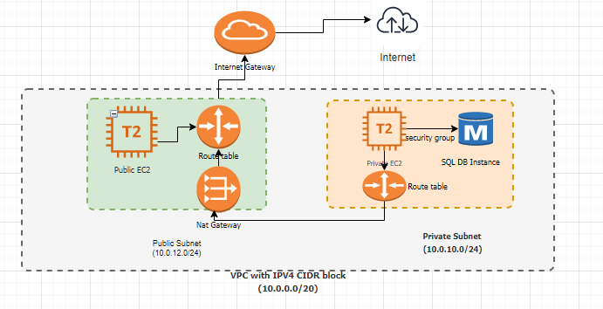

* Created MYSQL DB instance in private DB subnet group and security group inbound rule defined with source as **Private EC2 instance** security group

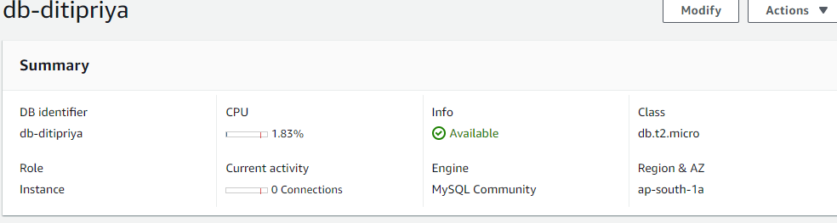

* Created a T2.Micro on demand EC2 instance in public subnet in user defined VPC

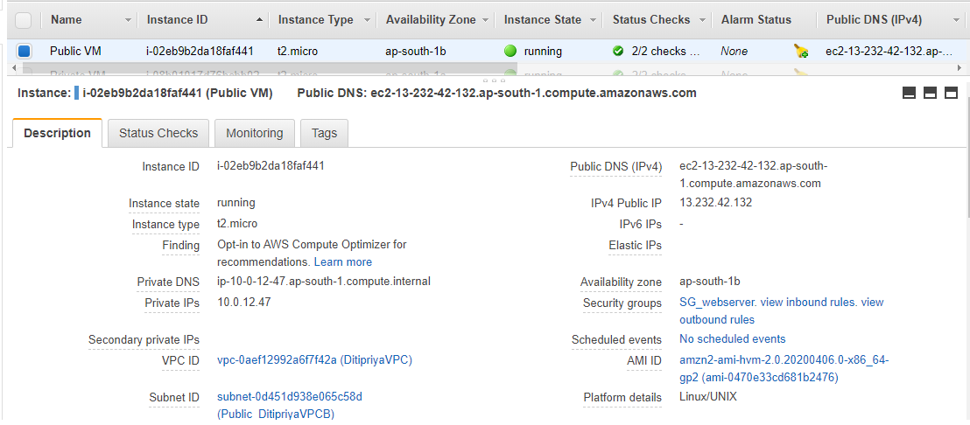

* Security group of public EC2 instance is defined with inbound rules accepting traffic from my IP address and outbound rules allowing all traffic going out.

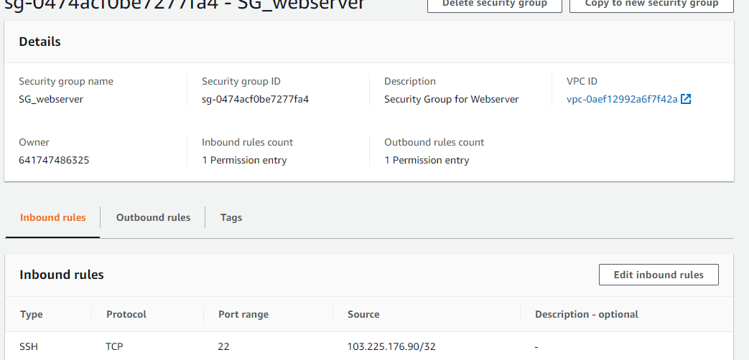

* Created T2 micro private EC2 instance.

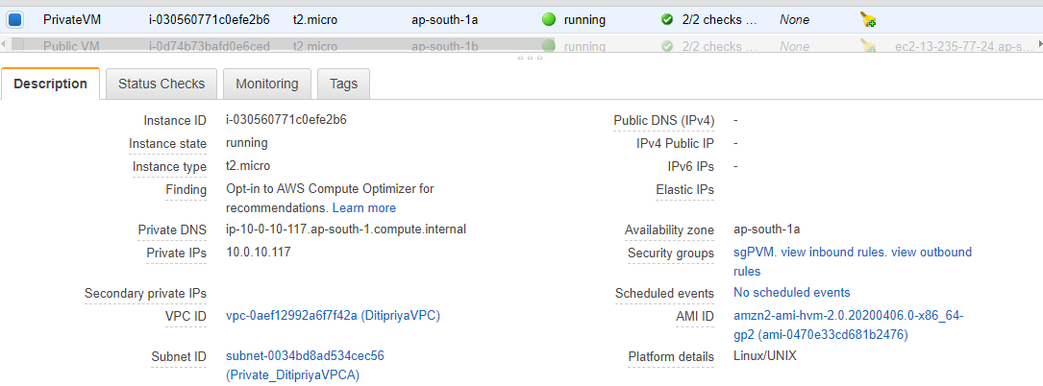

* SSH Public EC2 instance using Putty and installing all packages and connect private EC2 from public EC2 instance using SSH command from console and connect MYSQL DB instance from private EC2.

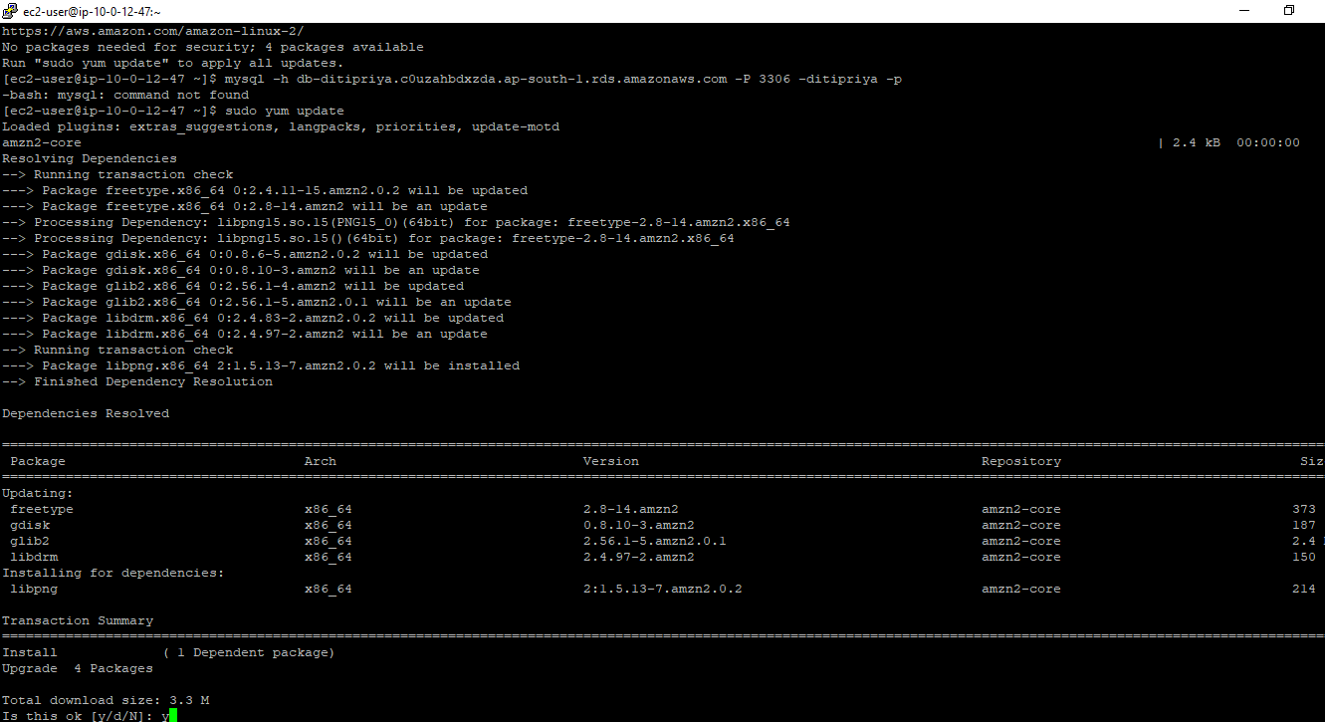

* Install MYSQL client in private EC2 , sudo yum install mysql –y and then executing following command to access MYSQL RDS instance being placed in private subnet from private VM



